
АХМЕДОВА Гулбану Калбайкызы,
№4 Балжан Бөлтірікова атындағы мектеп-лицейінің ағылшын тілі пәні мұғалімі.
Жамбыл облысы, Қордай ауданы

WHY IS ERIC A SUPERHERO?

Learning objectives | 4.1.2.1 — understand with support the main points of short, simple texts on familiar topics;  4.2.3.1 — use Present Simple forms to talk about everyday routines and habits.
Lesson objectives  (assessment criteria) | Learners will be able to:  -listen and understand the text about Eric the superhero;  -talk about Eric’s actions using key vocabulary;  -use Present Simple in affirmative and question forms.
Instilling values of the program “Birtutas tarbiye” | Responsibility – Appreciate how helping others (like Eric) makes someone a superhero. Respect & Cooperation – Practice polite turn-taking and teamwork in dialogues.Love for Homeland – strengthening national identity, cultural awareness, and civic responsibility
Stages/  Time | Teachers actions | Students actions | Assessment | Resources
Beginning  10 min | Greeting.  Teacher greets the students. Before the lesson starts, students say kind words to each other  She starts the lesson with basic question:  - What’s the date today?  - Who’s upsent?  - What’s the day of week, etc.  Activity 1.Checking homework – Puzzles  Divide the students into teams and ask members of each team to come up to the board. Show one of the words from the previous lesson in the singular form using a flashcard and tell the participants that they need to say the plural form of the word and then translate it. The first participant to do it correctly gets a point for their team.  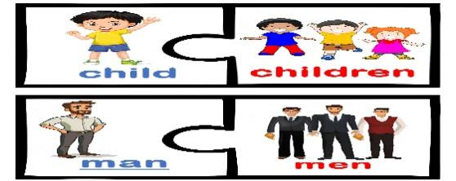  Brainstorming:  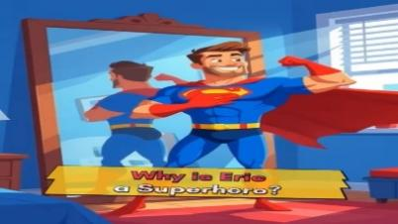  • Who is this man?  • What is he wearing?  • What colour is his costume?  • Is he happy or sad?  • Is he strong?  • What can superheroes do?  • Do you like superheroes?  • Who is your favourite superhero?  • Do you want to be a superhero? Why?  • What do you think our lesson is about today? | Students greet the teacher and answer to questions  Students find the answers |   “Well done”  “Good job”  Descriptor:  – say the plural form of the noun  1 point | Pictures or flashcards  Board  Flashcards
Middle  30 min | Presentation the new words  Teacher demonstrate the AI video with new words  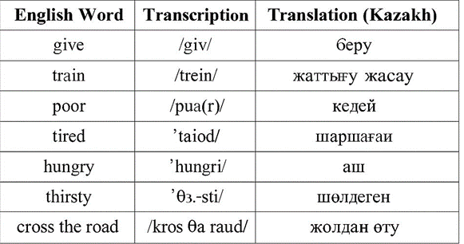  Activity 2. Grammar focus  Present Simple  Activity 3. Listen and answer, Why is Eric a superhero?  “Look at the pictures – what do you see? Yes, two boys and a man dressed as a superhero. Let’s listen to a text about Eric and find out why he’s called a superhero. Follow the pictures as you listen.  Asks comprehension questions:  1. Who is Eric?  2. What does he do on Saturdays?  3. Who does he help?  4. What time does he get up?  5. Does he help animals?  Activity 4. Platform True\ False  After listening or reading, decide if the sentences are true or false.  Eric is a doctor. — ☐ True ☐ False  He gets up at six o’clock. — ☐ True ☐ False  He drinks tea and eats bread for breakfast. — ☐ True ☐ Fals  He goes to school by bus. — ☐ True ☐ False  He watches TV all night. — ☐ True ☐ False  Activity 5. Fingers Matching  Match the halves  Warm-up « I’m so happy»  Activity 6. Group work  Group 1: “Eric’s Day” – make a poster showing Eric’s daily routine.  Group 2. Put the new words in the correct places and make sentences.  Conclusion  Activity 7. Speaking. «Superhero in my life» | Students repeat after the AI video  Students watch an AI-created video on the board and then answer the questions. | Descriptor:  - Answers the question: Why is Eric a superhero?  2 points  Descriptor:  -reads the sentences carefully.  - Understands the main idea and details of the text.  -Identifies whether each sentence is true or false  2 points  Descriptor:  understands the meaning of each sentence.  - matches the correct halves logically.  Descriptor: 1st group  -works together with group members to make the poster.  -describes Eric’s daily routine correctly and clearly.  -uses new vocabulary and correct grammar.  3 points  Descriptor: 2nd group  -works actively and cooperatively in the group.  -understands the meaning of new words.  -puts the new words in the correct places in sentences  3 points  Descriptor:  -talks about a person who is important in their life.  -uses correct vocabulary and grammar.  -speaks clearly and confidently in front of the class.  3 points
End  5 min | REFLECTION Padlet Students use their phones to write about today’s lesson on the Padlet board.  Saying good-bye |  |  | Padlet

